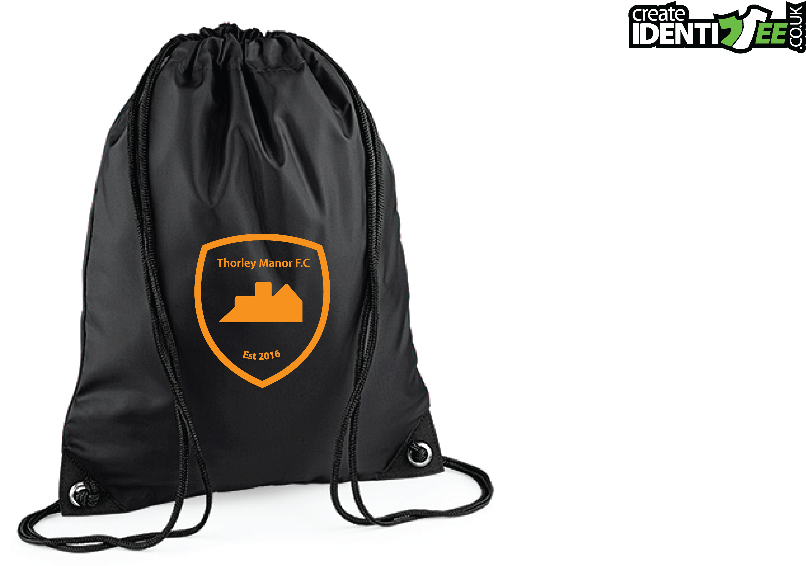
TRAINING PACKS

A follow up to my earlier email regarding training resuming on a limited basis. As I mentioned, there will be a need to provide individual kit for all the children so that we protect them during the current COVID situation. Our priority is to keep the kids safe and still ensure they have the opportunity to enjoy their football.

The kit will be provided by the club and this will be a significant expenditure to the club of over £1000. Therefore, I would like to ask if any of the parents know of any sponsors that would be willing to help us provide this. We have been lucky enough that 1 parent has contributed a big chunk of the amount but we still need to try and make the other half up. Failing this we like to ask for a voluntary contribution of up to £25 (any amount is appreciated) to cover the cost of the kit. I appreciate these are difficult times for everyone and this is completely voluntary. The club will be providing kit for all children and if you are not able to contribute it will not affect your child's ability to train. The club will support all the children and will ensure everyone has kit and is able to return to training and playing as soon as we can.

Thank you for any support you can give, no matter how small. It will all help support the club.

